**UECM3033 Assignment #1 Report**

* Prepared by: **LIM SIP YEE**
* Tutorial Group: T3

**Task 1 -- setup a github repository**

The reports, codes and supporting documents are uploaded to Github at:

<https://github.com/sipyeelim/UECM3033_assign1.git>

**Task 2 -- setup python**

Put here the screen shot of file (python.png)

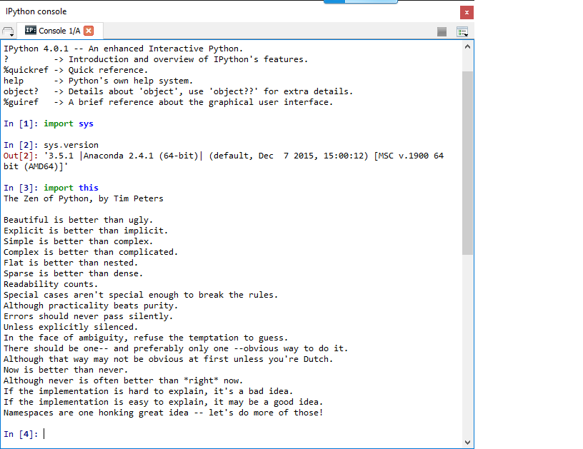

**Task 3 -- modify and run Python script**

In this section, please report:

1. The hexadecimal value of your student ID.

Hexadecimal representation of 1202348 is 0x1258ac

1. Write down the definite integrals that you have chosen.

$$\int_{0}^{\frac{π^{2}}{4}}{\sin\left(\sqrt{x}\right)\cos\left(\sqrt{x}\right)=\frac{π}{4}}$$

1. Write down your system of 10 linear equations.

$${1x}_{0+}3x_{1}+5x_{2}+9x_{3}+10x_{4}+15x_{5}+16x_{6}+14x_{7}+12x_{8}+4x_{9}=5$$

$$10x_{0+}9x_{1}+8x_{2}+7x_{3}+6x_{4}+5x_{5}+4x_{6}+3x_{7}+2x_{8}+1x_{9}=6$$

$$1x_{0+}8x_{1}+6x_{2}+2x_{3}+3x_{4}+20x_{5}+5x_{6}+4x_{7}+8x_{8}+5x_{9}=7$$

$$6x_{0+}4x_{1}+60x_{2}+70x_{3}+40x_{4}+80x_{5}+70x_{6}+9x_{7}+11x_{8}+10x_{9}=8$$

$$1x_{0+}2x_{1}+3x_{2}+{7x}_{3}+{8x}_{4}+{9x}_{5}+{4x}_{6}+{5x}_{7}+{6x}_{8}+{1x}_{9}=10$$

$$2x_{0+}15x_{1}+{13x}_{2}+11x_{3}+74x_{4}+50x_{5}+65x_{6}+66x_{7}+{60x}_{8}+{40x}_{9}=12$$

$$2x_{0+}3x_{1}+2x_{2}+1x_{3}+2x_{4}+6x_{5}+2x_{6}+8x_{7}+2x_{8}+7x_{9}=15$$

$$8x_{0+}5x_{1}+6x_{2}+5x_{3}+4x_{4}+3x_{5}+2x_{6}+1x_{7}+5x_{8}+2x_{9}=17$$

$$5x_{0+}6x_{1}+4x_{2}+3x_{3}+2x_{4}+1x_{5}+1x_{6}+2x_{7}+3x_{8}+4x_{9}=9$$

$$2x_{0+}3x_{1}+4x_{2}+5x_{3}+6x_{4}+6x_{5}+6x_{6}+7x_{7}+8x_{8}+10x_{9}=8$$

$X_{0}=-3.96400114$

$$X_{1}=-3.0166911$$

$$X_{2}=13.76900902$$

$X_{3}=$-2.74645516

$X_{4}=$-0.64577709

$X_{5}=$-2.22767936

$X_{6}=$-6.40154555

$X_{7}=$ 6.28106672

$X_{8}=$ 3.42308384

$X_{9}=$-3.20678104

last modified: 28/01/2016